**Global Accelerator**

AWS Global Accelerator is a service that improves the availability and performance of your applications with local or global users. It provides static IP addresses that act as a fixed entry point to your application endpoints in a single or multiple AWS Regions, and uses the AWS global network to optimize the path from your users to your applications.

Create two instances in two different regions

**N.Virginia**

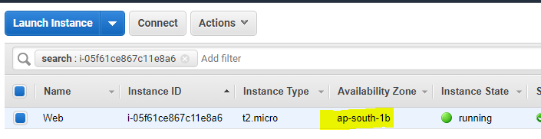

**Mumbai**

